MINI PROJECT 2
FLOW CHART
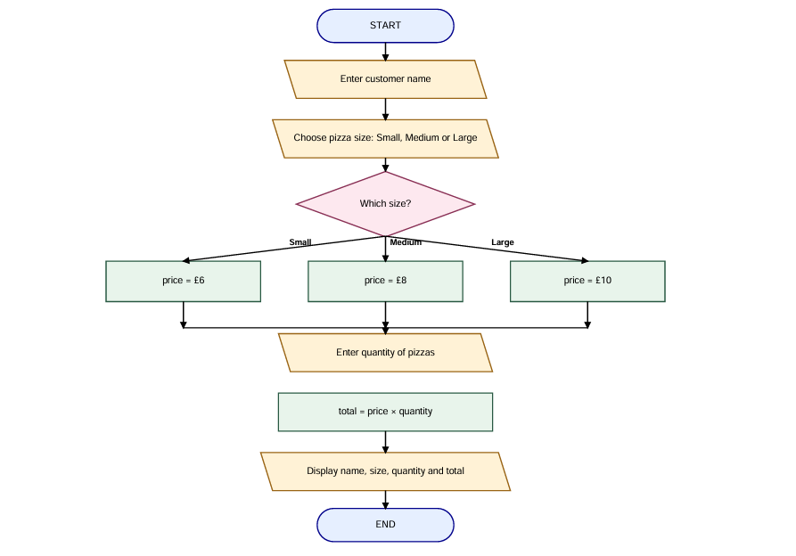
TEST PLAN

TEST | INPUT | RESULT
1. | NAME : JHON SIZE : SMALL . QUANTITY 1 | SHOWS ALI AND 6£
2. | NAME : PETE SIZE : MEDIUM . QUANTITY 2 | £8 *2=£16
3. | NAME : HARRY SIZE :LARGE. QUANTITY 3 | £10 *3=£30
4. | NAME : TOM SIZE : SMALL . QUANTITY 4 | £6 *4=£24
5. | NAME : JOSH SIZE :MEDIUM. QUANTITY 0 | CALULATES £0
6. | ENTER INVALID PIZZA SIZE | IT WILL ASK FOE SIZE

